Name/Primary Contact_____________________________________________________________________________

Business & Owner’s Name__________________________________________________________________________
Address_________________________________________________________________________________________
City__________________________________________________________ State_______ Zip Code_____________
Mobile Phone_____________________________ Email__________________________________________________
Emergency Contact & Phone Number_________________________________________________________________

Form of Payments Accepted (please circle all that apply): Cash Only Card Only Cash or Card Apple/Android

*****PLEASE NOTE: With your application, you MUST provide a copy of your sales permit which is required by the State of Wisconsin and Waukesha County in addition to PROOF OF INSURANCE including your insurance carrier and policy number.*****

ENTER YOUR 15 DIGIT WISCONSIN SALES PERMIT NUMBER
456-__________________________-______________________________

If you do not have a Wisconsin seller permit number and claim your sales are tax-exempt, enter the exception code number from the following table:
1-all sales are exempt sales only or display only
2- multi-level marketing company pays sales tax
3-non-profit exemption
4- Exempt occasional sales
EXEMPTION CODE:
______

FEES-Per Stall Spacing
 |  | NO VEHICLE |  |  |  |  | WITH VEHICLE
HOURS 8AM-12PM Snow/Rain or Shine | How Many | SINGLE DAILY | SINGLE | DOUBLE | TRIPLE | Non-Proifit Daily |  | SINGLE DAILY | SINGLE | DOUBLE | TRIPLE | Premium stall  400s row
Off Peak Season (1st or last 7 weeks) | 7 | $40 | $250 | $475 | $ 700 | $10 |  | $50 | $325 | $625 | $925 | N/A
Peak Season (June 22 - Oct 26) | 19 | $40 | $375 | $700 | $1000 | $10 |  | $50 | $450 | $850 | $1,225 | $50
Full Season (May 4 - Oct 26) | 26 | $40 | $425 | $800 | $1,150 | $10 |  | $50 | $500 | $950 | $1,375 | $50

Please circle the pricing plan that fits your business. Add a $50 one-time vetting fee if you are a first-time vendor. Subtract a $50 early-bird discount if you are a returning vendor and have a completed application submitted by February 23rd, 2024. Subtract $25 if you are paying in full for your seasonal stall(s)

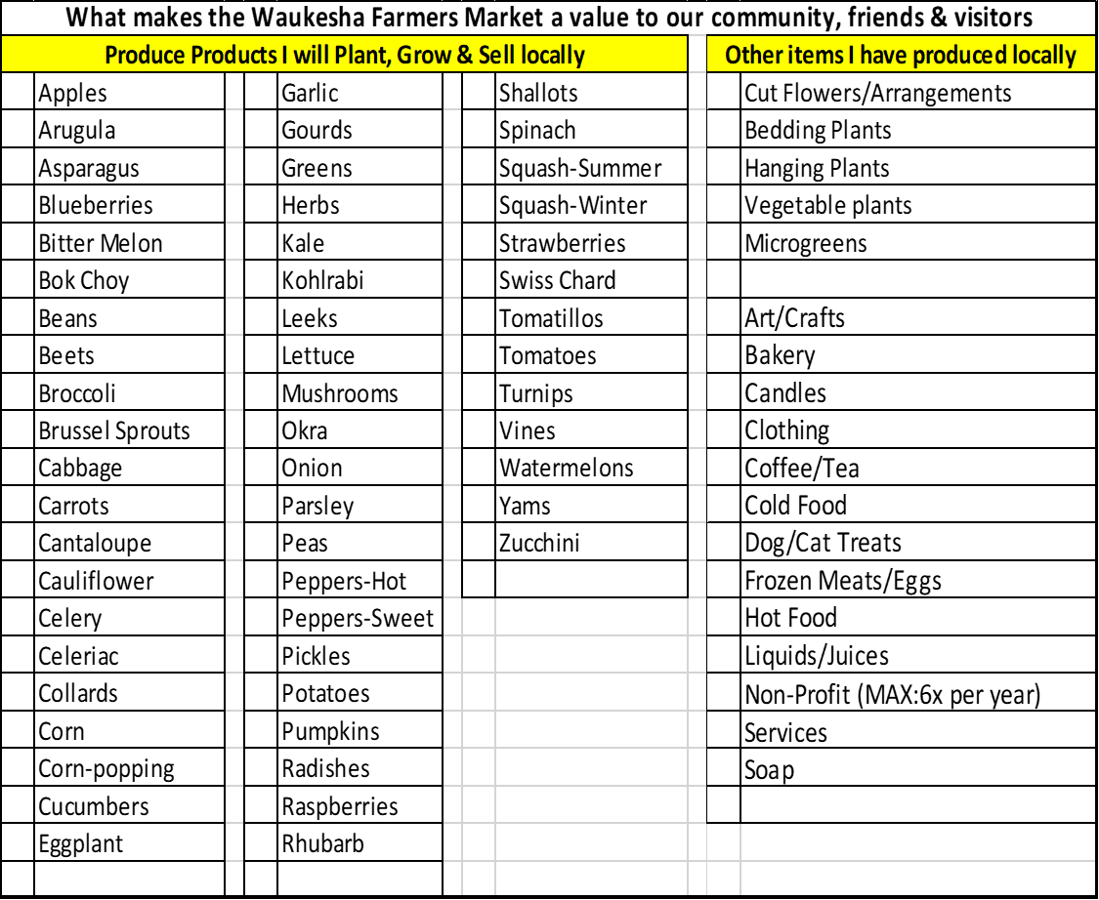
****Please indicate what you will be selling, if items are not listed, please write them in****
SIGNATURE PAGE:

The renter of a market stall(s) holds harmless the Waukesha Downtown Business Association (WDBA) and Waukesha State Bank from and against all causes of action, claims, demands, suits, liability, or expense by reason of loss or damage to any property or bodily injury to any person, including death, as direct or indirect result of use of any rented or occupied market space or in connection with any action or omission of the renter who shall defend the above, Waukesha Downtown Business Association (WDBA) and Waukesha State Bank in any such cause of action or claim. By signing this form, I agree to an inspection of my growing/producing area and confirm that I have read, understand and will follow the guideline rules of the Waukesha Farmers’ Market.

I also hereby grant the WDBA the irrevocable right to use my image & voice in any recordings on their social media platforms. I waive the right to approve the final product. I hereby release the WDBA from any and all claims for invasion of privacy, appropriation of likeness or defamation. I understand that any video or image will have distribution limited to the WDBA’s immediate media pages and printed newsletters distributed between WDBA members and customers of the Waukesha Farmers Market.

The success of our farmers’ market is greatly aided by supporting social media efforts. We ask every vendor to help us spread the word on your own social media about Waukesha’s Farmers’ Market, its vendors, their products, and downtown Waukesha events.

_______________________________________________________________________ ____________________
Vendor Signature Date
Please return this form with all sections filled in, along with your Certificate of Liability Insurance listing Waukesha State Bank and the Waukesha Downtown Business Association as Additional Insureds, minimum liability coverage of $100,000/$300,000 aggregate, and full payment by February 23rd, 2024 to get your $50 early bird discount. Applications received after February 23rd will not receive the $50 discount.
Mail or drop off applications at 235 W. Broadway St., Waukesha, WI 53186 (there is a drop-box for after hours)
Checks are to be made payable to: Waukesha Downtown Business Association (WDBA). If you want to request a certain booth, please include your booth number and return the application by 2/23/24. We will do our best to accommodate all requests but offer no guarantees. Approved vendors will receive their stall assignment in April.
Please check here if requesting use of a generator.
Please note that ALL generators for 2024 must be INVERTER generators to reduce noise pollution.
Success checklist:
Completed Application and Applicable Permits (Food, Seller’s, etc.)
Enclosed Payment
Current Insurance Certificate

